CHAPTER 1

OVERVIEW

* 1. **Introduction**

Conjugated polymers (CPs) are a class of organic semiconducting materials that have been widely studied over the past few decades, owing to their use as active materials for low-cost photovoltaic (PV) and light-emitting diode (LED) technologies.{Dennler, 2005 #10}{Yim, 2008 #56}{McNeill, 2000 #32}{Rothe, 2006 #177} These materials exhibit efficient emission in the UV and visible spectrum (fluorescence quantum yields ranging from ~30% to nearly 80%),{Greenham, 1995 #202}{Pei, 1996 #203} as well as efficient energy and charge transport.{McNeill, 2002 #30}{Lunt, 2009 #27} The observed fluorescence emission in the UV-visible spectrum is due to the structure and heteroatoms that comprise each monomer unit, as well as the extended -conjugation along the polymer backbone.{Wu, 2006 #48}{Meier, 1997 #204} To improve upon existing technologies, it is necessary to further understand the disordered, heterogeneous photophysics and energy transport phenomena observed in CP thin films and devices. Specifically, it is beneficial to understand how intrinsic defects and polymer structure and conformation affect these processes. Conjugated polymer nanoparticles (CPNs) exhibit similar photophysics to those of CP thin films, but offer greater control over polymer structure compared to thin films via particle size control. By extension, this provides a more reliable means of controlling nanoscale interactions that lead to heterogeneous dynamics in CPs.

CPNs are also ideal for use in fluorescence imaging applications for a variety of reasons. They possess small (4-30 nm) particle diameters, and are easily functionalized and encapsulated.{Wu, 2010 #53}{Wu, 2006 #178} The photostability figures of merit for CPNs such as ~109 photons emitted prior to irreversible photobleaching and photobleaching quantum yields of ~10-9 are several orders of magnitude better than conventional small molecule dyes and current fluorescent probes. In addition, CPNs exhibit exceptional absorption and fluorescence characteristics, including extinction coefficients of ~109 M-1 cm-1 compared to dyes (~104 – 105 M-1 cm-1), absorption cross sections of ~10-13 cm2, and radiative rates of ~108 photons/s.{Wu, 2008 #51}{Johansson, 1991 #205} Improvements in nanoparticle fluorescence quantum yield and red-shifting of emission are required for effective use in complex biological samples to ensure sufficient signal-to-noise ratios and to overcome background fluorescence inherent in biological media.{Ntziachristos, 2006 #34}

The chapters within this dissertation principally focus on steady-state and time-resolved fluorescence spectroscopy of conjugated polymer nanoparticles and solutions with the goal of better understanding exciton transport in CPNs. In particular, we examine the effect of nanoscale disorder (i.e., the presence of structural and/or chemical defects within CP chains) on the excited state kinetics and spectra of CPNs. We also estimate the exciton diffusion length and exciton diffusion rates in CPNs and linear CPs for optimization of devices based on amorphous organic semiconductors. In addition, we aim to improve the fluorescence characteristics of CPNs (e.g. brightness and red-shifting of emission) for fluorescence imaging applications. Chapter 2 describes the materials, experimental methods, spectroscopic techniques, and instruments utilized in this research. Chapter 3 details the use of dye doping and polymer blending in CPNs with the aim of improving fluorescence brightness and red-shifting emission for fluorescence imaging applications, as well as to estimate the exciton diffusion length while accounting for defects in CPNs. Chapter 4 delineates the use of solvent-induced swelling coupled with time-resolved fluorescence anisotropy decay measurements to determine the rate of exciton transport in undoped CPNs compared to the linear polymer, as well as to assess the reversibility of quenching by defects via swelling. Both projects utilize a combination of steady-state and time-resolved spectroscopy in conjunction with Monte Carlo simulation to address these issues from multiple angles.

* 1. **Conjugated Polymer Device Structure**

Conjugated polymers have been utilized in several device types including photovoltaics and LEDs. Thin films are used in these devices in order to minimize device size and due to the need to layer active materials specifically for electron and hole injection and transport, or as an emissive material layer. In a typical organic photovoltaic (c.f. Fig 1.1), a substrate such as glass is deposited with several thin films, the first being an optically transparent conducting anode material that acts as a hole injection material (e.g. indium tin oxide, ITO). Due to the efficiency of energy transport and hole transport, hole-conducting CPs such as the ones used in this research would comprise the hole transport material in these devices. An efficient electron transport layer material (e.g. thiophene polymer, fullerene polymer) is blended with the hole transport material in the same solution, and then the blend is deposited on top of the cathode, forming a bulk heterojunction. A metal cathode (typically aluminum) is deposited on top of the bulk heterojunction. In these devices, neutral photoexcitations known as Frenkel excitons (described in the next section) are generated in the bulk heterojunction where the hole and electron transport materials overlap, and the neutral exciton is separated into individual charges (electrons, holes) via charge transfer. The electron and hole are then transported through the respective transport layers to the cathode or anode, generating electrical current in the device. {Heeger, 2014 #193}{Günes, 2007 #191}{Adams, 1999 #1} Running a similar device in reverse produces light (as charges recombine and excitons decay radiatively), and is the basis of organic LED technology. The efficiency of these devices is determined partially by the work functions of the cathode and anode materials, as well as the efficiency of charge transfer and recombination. Typical power conversion efficiencies for these devices are up to ~9% for OPVs (similar to quantum dot based PVs), and up to 8% for OLEDs (compared to ~10% for quantum dot LEDs).{Dennler, 2005 #10}{Günes, 2007 #191}{Chuang, 2014 #229}{Cao, 1999 #192}{Heeger, 2014 #193}{Shen, 2015 #230}

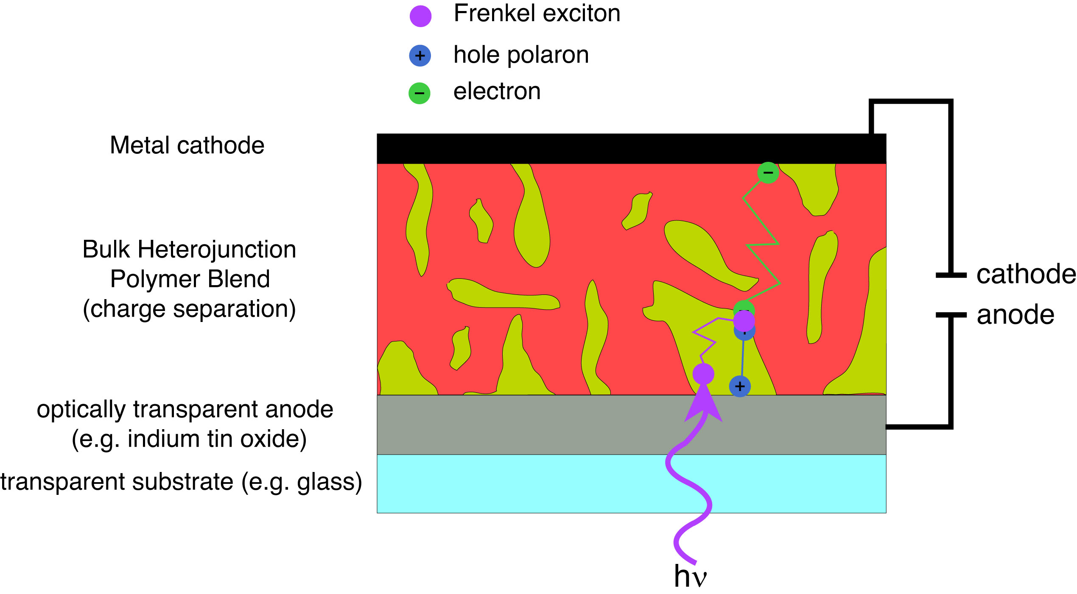

Fig. 1.1. Schematic of a typical bulk heterojunction organic photovoltaic/LED device depicting exciton generation and exciton, electron, and hole transport.

* 1. **Frenkel Excitons in Conjugated Polymers**

The energetic characteristics of conjugated polymers arise from the extended -conjugation (alternating single and double bonds) along the polymer backbone. Upon absorption of a photon, an electron is excited from the  to * electronic band, generating a neutral excitation that is delocalized (through strongly coupled transition dipoles) along a segment of the polymer, known as a Frenkel (or molecular) exciton.{Frenkel, 1931 #224} This conjugated segment is referred to as a chromophore, which is typically comprised of 2-8 monomer units in CPs and CPNs.

Transition dipole coupling strength determines whether or not excitons form in CPs, as well as exciton size in CPs. Transition dipole coupling is also involved in the typically dominant forms of energy transport depending on the magnitude of the coupling strength, temperature, and the amount of disorder in the polymer. What follows is a presentation of a simplified theory for Frenkel-like excitons, based loosely on the theory as presented in a review by Kasha et al.,{Kasha, 1963 #186} but omitting several higher-order effects and expressed in more modern notation. Here the discussion is limited to the basic features, key interactions, and some of the key phenomena such as Davydov splitting, “dark” excitons, and delocalized excitations or coherent energy transport. More rigorous, extensive, higher-level discussions including many phenomena not discussed here are provided by Silinsh and Capek {Silinsh, 1997 #225} and Pope and Swenberg.{Pope, 1999 #226} In CPs, chromophores are formed as a result of the delocalization of pz orbitals between degenerate monomers. Chromophore size is dictated by the number of conjugated monomers (typically 2-10 monomers per chromophore). Then, interactions between transition dipoles of two or more degenerate chromophores result in Frenkel (or molecular) excitons,{Frenkel, 1931 #224} which can be described using perturbation theory. The coupling strength is quantified via the perturbation to the energy of the electronic states of the interacting monomers. As a brief review, it can be shown that given a perturbed Hamiltonian that solves the Schrödinger equation

, (1.1)

where and are the unperturbed Hamiltonian and energy, respectively, is the perturbation, we can determine , which is the average shift to the energy as a result of the perturbation, and the effect of the perturbation on the state (discussed below). Following excitation, a CP chromophore is in a metastable state that is assumed to be stationary, and transition dipole coupling of non-degenerate chromophores has the potential to result in energy transfer from one chromophore to another (i.e. heterotransfer/hetero-FRET) at long times. The coupling strength is given by

, (1.2)

where corresponds to the unperturbed state, and is the transition dipole coupling between chromophores, proportional to . The perturbed state (to first order) is given by

. (1.3)

The second term on the right side of Eq. 1.3 suggests that only states that are closer in energy to the excited state energy mix appreciably with the state (which will be reflected in the spectral overlap conditions of FRET, detailed in section 1.4). For degenerate chromophore interactions

, (1.4)

the first-order correction to the *D* degenerate chromophore energies is given by Eq. 1.2 for *n* = 1, 2,…*D*. These corrections correspond to the roots of the resulting secular determinant given by

(1.5)

for *n, m* = 1, 2,…D where (if the degeneracy is removed completely in first-order), and it is assumed that the correct zero-order wavefunctions

(1.6)

that diagonalize the secular determinant are used.{Levine, 2000 #182} Equation 1.6 can be substituted for in Equation 1.3 for the first order wavefunction correction (where the second term corresponding to is assumed to be negligible for states outside of the degenerate set of chromophores). Thus, the perturbation acting on a set of degenerate (or nearly degenerate) electronic states results in either partial or complete splitting of the previously degenerate energy levels of the individual monomers sharing the excitation (Davydov splitting),{Davydov, 2008 #231}. The resulting Davydov splitting leads to energy shifting of the UV-Vis and fluorescence spectra of CPs in the nanoparticle or thin film state due to interchain and/or intrachain interactions as well as changes in the transition strength. In the simplest case of two identical chromophores interacting through their transition dipole moments, the first-order energy corrections and are , respectively. Depending on the magnitude of the coupling strength , the expansion coefficients in Eq. 1.6 vary. If is weak compared to the energy difference between coupled states, the reflect this by having most of the excitation on one monomer, and the other near zero (the exciton is shared incoherently, as in homo-FRET). For perfect degeneracy and/or strong transition dipole coupling, the excitation is shared equally amongst the participating monomers ().

Excitons are able to migrate along or between polymer chains via several processes, including incoherent processes such as Förster resonance energy transfer (FRET) and Dexter electron transfer (described in detail in section 1.4), or by coherent energy transfer; all of these processes encompass what is often referred to as “exciton diffusion,”{Scholes, 2006 #36} or multiple energy transfer. These terms will be used interchangeably in this dissertation; however, the latter term arises from the assumption that most of the observable exciton transport at or above the picosecond time scale is due to incoherent energy transfer processes, and thus progresses as a series of multiple discrete energy transfer events. Nevertheless, understanding coherent transfer is critical to understanding the nature of excitons and exciton diffusion in conjugated polymer systems.

Coherent energy transfer is understood upon calculation of the time-dependent probability of an electron tunneling between strongly coupled, degenerate monomers. For the aforementioned two-molecule system, the probability amplitude of an electron tunneling from a molecule in state to a degenerate molecule in state is given by

, (1.7)

where , and is the reduced Planck constant . The resulting tunneling probability is given by . Thus, the probability of finding the excited state electron on one of the participating monomers oscillates back and forth between the coupled monomer units with a tunneling (energy transfer) rate constant of . This tunneling process occurs on the femtosecond time scale, and represents the strong coupling or coherent limit and is a good approximation as long as thermal disorder and energetic disorder are low relative to the coupling strength. Given a set of chromophores with strongly coupled transition dipoles, an excitation on one of the chromophores will yield an oscillating excitation across the set of interacting chromophores. Förster transfer between identical chromophores involves the same basic physical picture, but thermal or energetic disorder breaks up the coherence and the mixing of the states (introduces additional frequencies in Eq. 1.7), and the resulting transport process is better described as excitation localized on a single chromophore undergoing hopping via an incoherent process. The relative contributions of FRET, Dexter transfer, and coherent transfer can be understood by the ratio of , where is the Boltzmann constant times temperature. For systems with 1, exciton formation dominates, and coherent transfer is the primary means of energy transport. For systems where 1, neighboring monomers (and chromophores) do not interact strongly, thus limiting chromophore size and/or coherent transfer between like chromophores.{Kasha, 1963 #186}{Köhler, 2011 #194} It is important to note that the underlying physical picture and interactions are the same for homo-FRET and the Frenkel picture. For low coupling strengths, homo-FRET and/or Dexter transfer dominate, depending on the degree of molecular orbital overlap and alignment of transition dipoles. However, for high coupling strengths, the contributions of FRET and Dexter transfer are smaller by comparison.{Kasha, 1963 #186}{Athanasopoulos, 2013 #3}

As mentioned above, temperature and disorder in CPs and CPNs also affect the rate of exciton transport. At high temperatures (e.g. room temperature) excitons can resonantly couple to optical phonons (exciton-phonon coupling), which breaks up exciton coherence, forcing exciton transport to occur via incoherent, phonon-assisted processes. At low temperatures, exciton transport is dominated by coherent energy transfer.{Athanasopoulos, 2013 #3}{Meskers, 2001 #196}{Lim, 2004 #237}{Roden, 2009 #238} Conformational variability and/or chemical defects in the CP chain give rise to energetic disorder that can affect various excited state processes as well as lead to shifts in emission spectra. Conformational variability (structural defects, i.e. bends or kinks in the polymer chain) arise most commonly in aggregated CP samples such as nanoparticles or thin films, whereas chemical defects in CPs are often the result of oxidation of the polymer (e.g. fluorenone/keto defects in polyfluorenes) or side products in the polymerization reaction.{Hintschich, 2003 #19} The presence of various defects result in conjugation breaks along CP chains, which in turn yields inhomogeneous broadening of optical spectra due to the distribution of exciton energies associated with a random distribution of conjugation lengths within the polymer. {Dias, 2006 #197} Disorder also broadens the distribution of fluorescence lifetimes within CPs and CPNs, leading to fluorescence intensity decays characterized by complex exponential functions.

Exciton transport is not limited to singlet excited states. Singlet excitons may undergo intersystem crossing to form triplet excitons, which are typically much longer lived (ns-ms) compared to singlet excitons (fs-ns), and can have higher non-radiative decay rates (as in PPV-based polymers) than radiative (phosphorescence) decay rates.{Colaneri, 1990 #235}{Ikeyama, 1985 #234} As such, triplet excitons in conjugated polymers are sometimes termed “dark excitons.”{Shuai, 2000 #236} Like singlet excitons, triplet excitons are capable of both coherent and incoherent transfer pathways. However, incoherent triplet exciton transport is restricted to nearest-neighbor mechanisms such as Dexter electron transfer (c.f. Section 1.4). As such, triplet exciton diffusion constants are typically much less than singlet exciton diffusion constants (typically by ~1-3 orders of magnitude).{Lunt, 2009 #27}{Groff, 2013 #60}

**1.3.1 Exciton Decay Processes in CPs**

In addition to the exciton diffusion processes mentioned above, there are various decay processes in CPs and CPNs that determine the fate of a given exciton after photon absorption (c.f Fig 1.2).

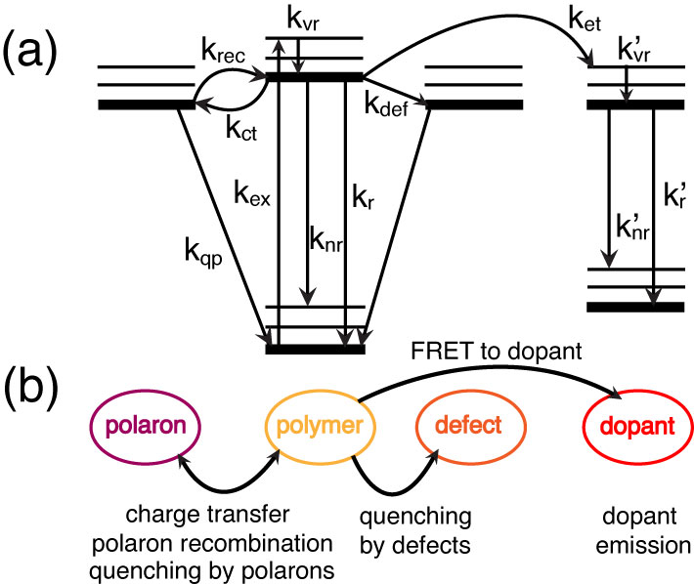

Fig. 1.2. (a) Jablonski diagram illustrating the exciton decay processes in doped CPNs. (b) Illustration relating the rate processes in (a) to their respective physical observables.

After vibrational relaxation to the ground vibrational state of the excited electronic state (kvr), an exciton may either decay radiatively (kr), or non-radiatively via internal conversion (knr). The exciton may also undergo Förster resonance energy transfer (FRET) to a defect site (kdef) where the exciton is quenched. Excitons may undergo charge transfer to form hole polarons (kct, discussed later), or the hole and electron recombine to reform the neutral exciton (krec). If subsequent excitons are generated in the vicinity of a polaron, they may be quenched by the polaron (kqp). If a dopant species is introduced into the system, an exciton may undergo FRET to the dopant (ket, discussed below), where similar processes apply if the dopant is a conjugated polymer, or radiative and non-radiative decay may occur if a fluorescent dye dopant is used.

* 1. **Förster Resonance Energy Transfer (FRET) and Dexter Electron Transfer in CPs**

FRET and Dexter electron transfer are processes involving the transfer of an electronic excitation from molecule to another. If transfer occurs between like molecules (e.g. equivalent chromophores of a conjugated polymer), this is referred to as homotransfer or homo-FRET. If transfer occurs between chemically distinct molecules, this is referred to as heterotransfer. For either transfer process, the molecule initially excited by photon absorption to its singlet excited state is referred to as the donor, and the molecule that the excitation is transferred to is referred to as the acceptor. Both processes are non-radiative (there is no photon emission upon donor relaxation nor reabsorption of emission resulting in acceptor excitation), and have similar initial and final states. However, the path by which an excitation moves from one molecule to another differs. The differences between each process are discussed in detail below, and illustrated in Fig. 1.3.

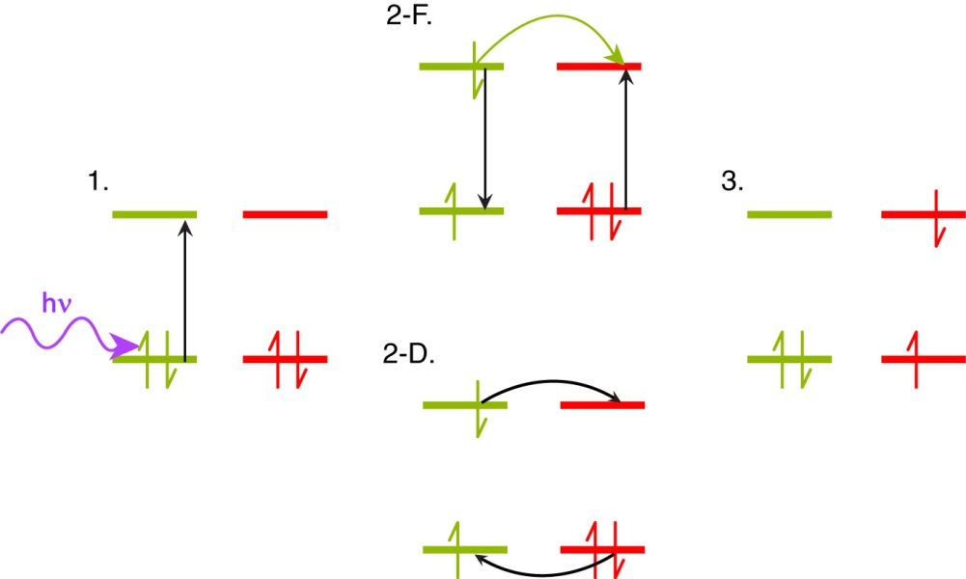

Fig. 1.3. Comparison of Förster and Dexter transfer, including illustration of the HOMO and LUMO orbitals of a donor (yellow) and acceptor (red) pair, with colored arrows to indicate photon absorption (purple), energy transfer (yellow), and electron motion (black). In the initial state (1), a HOMO donor electron is excited to the LUMO via photon absorption. The intermediate states illustrate the Förster resonance energy transfer (2-F) and Dexter electron transfer (2-D) processes. Both processes yield the same final state with the donor in the ground electronic state and an electron in the acceptor LUMO (3).

The process of FRET involves long-range (≤10 nm) transition dipole coupled energy transfer from the donor to the acceptor, resulting in non-radiative relaxation of the donor electron from the excited state back to the ground state, and concomitant HOMO🡪LUMO excitation in the acceptor.{Förster, 1948 #181} The FRET process is dependent upon several variables, including intermolecular separation, spectral overlap of the donor fluorescence spectrum with the acceptor absorption spectrum, and relative alignment of transition dipole moments between the donor and acceptor. It is convenient to define a distance *R*0 known as the Förster radius, where FRET between the donor and acceptor is 50% efficient (typically 1-6 nm).{Wiczk, 1991 #206}{Akrap, 2010 #207} This is given by the equation

, (1.1)



where *n* is the refractive index of the solvent, *N* is Avogadro’s number, *D* is the fluorescence quantum yield of the donor (a measure of the percentage of photon absorption events that result in fluorescence photons). **2 is the transition dipole orientation factor (typically assumed to be 2/3 for random transition dipole orientations), given by

, (1.2)



where the angle ** corresponds to the angle between the donor and acceptor transition dipole vectors, ** corresponds to the angle between the donor transition dipole vector and the intermolecular axis, and ** corresponds to the angle between the acceptor transition dipole vector and the intermolecular axis (c.f. Fig 1.4).

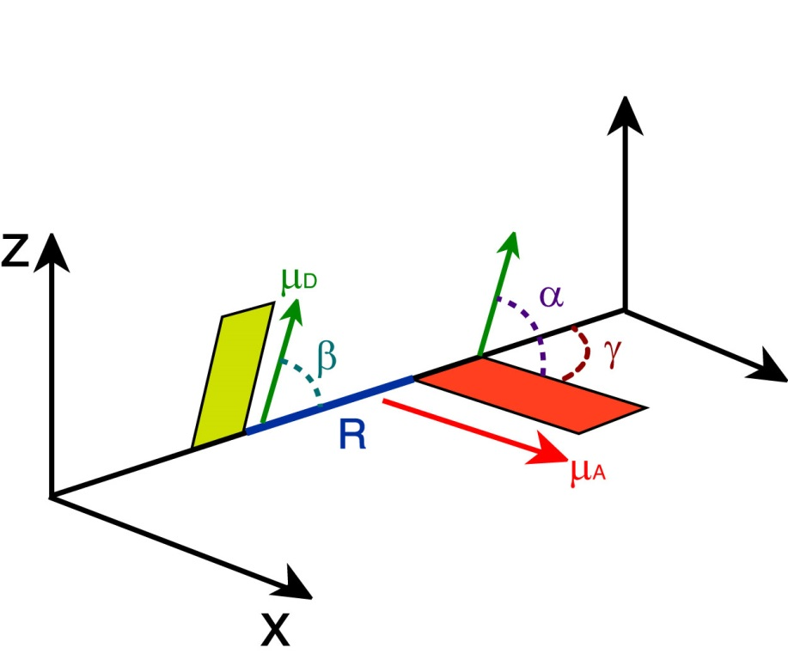

Fig. 1.4. Illustration of transition dipole vectors and angles used to calculate **2 for a donor and acceptor pair. D (green) and A (red) correspond to the donor and acceptor transition dipole vectors, R (blue) is the intermolecular distance along the intermolecular axis.

Lastly, *J*(**) is the spectral overlap integral, calculated by

, (1.3)



where ** and *d* are the wavelength and wavelength spacing, respectively, *FD*(**) is the normalized emission spectrum of the donor, and *A*(**) is the extinction spectrum of the acceptor (converted from the absorption spectrum using Beer’s Law). The energy transfer rate constant (*ket*) is determined using the Förster radius by

, (1.4)



where *R* is the intermolecular separation and 0 is the fluorescence lifetime of the donor. FRET is a useful tool for measuring interactions between molecules for distances <10 nm, and is often referred to as a “molecular ruler.”{Stryer, 1967 #172}{Stryer, 1978 #173}{Lakowicz, 2006 #26}

The dependence of the FRET rate constant on the inverse sixth power of intermolecular separation arises initially from the fact that FRET is facilitated by interacting excited-state transition dipoles, whose interaction potential is proportional to *R*-3 (taken to be a first-order perturbation between the excited donor and acceptor). The distinction of Förster transfer from previously mentioned coherent transfer is that Förster transfer is assumed for very weakly coupled transition dipoles, whereas coherent transfer requires strong coupling. From the time-dependent tunneling example described in section 1.3 (c.f. Equation 1.7), we see that the tunneling probability amplitude . We can approximate the sine function at early times as and thus , which yields an *R*-6 proportionality in the tunneling rate.

Despite sharing the same initial and final states with regard to donor and acceptor as FRET, the mechanism of Dexter transfer differs substantially from FRET. In Dexter transfer, an electron in the ground state (HOMO) of the acceptor is exchanged with an electron in the excited state (LUMO) of the donor. These electrons possess identical spins, and remain in similar electronic states (a LUMO donor electron is transferred to the LUMO of the acceptor, and a HOMO electron in the acceptor is transferred to the HOMO of the donor). The spin criterion holds true for singlet Dexter transfer, but not for triplet transfer, or triplet-triplet annihilation,{Monguzzi, 2008 #180} in which the transferred electrons possess opposite spins. The Dexter process is facilitated by molecular orbital (wavefunction) overlap, as well as spectral overlap of the donor fluorescence spectrum with the acceptor absorption spectrum. Given the former criterion, the Dexter transfer mechanism is very sensitive to changes in intermolecular separation. The distance-sensitivity of Dexter transfer is made clear upon inspection of the probability of electron exchange, given by:

, (1.5)



where *Z* is a constant (1), *J*(**) is the is the normalized spectral overlap integral given by Equation 1.3, *R* is the intermolecular separation (in angstroms), and *L* is the average of the van der Waals radii of the donor and acceptor (in angstroms). {Dexter, 1952 #176} Inspection of the exponential term alone in Equation 1.5 elucidates the distance sensitivity of Dexter transfer. Depending on the average van der Waals radius *L*, the probability of electron exchange falls to essentially zero within ~1-2 nm or less, and is reduced further depending on the spectral overlap and *Z*, proving that Dexter transfer is only efficient at very small intermolecular separations. However, for cases in which chromophores are tightly packed and Förster transfer is not favored (for example, due to unfavorable dipole alignment, or in the case of triplet excited states, which exhibit low acceptor extinction), Dexter transfer may be the dominant energy transfer mechanism.{Scholes, 2000 #227}

* 1. **Polarons in Conjugated Polymers**

Devices based on CPs require efficient charge transport in addition to efficient exciton transport in order to function properly. In these devices, charges are either injected into the polymer through cathode/anode materials, or formed by dissociation of excitons through charge transfer events in the bulk heterojunction (c.f. section 1.2). Additionally, many fluorescence measurements on conjugated polymers and nanoparticles are complicated by photoejection of charges at higher excitation powers, resulting in a leftover isolated charge on the polymer chain that quenches the excited state via charge-transfer complexation, or damages the polymer resulting in photobleaching. These isolated charges along with the polarized volume surrounding them within the polymer are treated as quasiparticles and referred to as polarons.

The majority of measurements performed in this research were performed in air, and thus the presence of oxygen provides an oxidizing environment. This is combined with the fact that under ambient conditions, the CPs used in this study are inherently hole-conducting/electron donating. As such, hole polarons are assumed to be the prominent type of polaron occurring in these CPs. However, under reducing conditions, or by using intrinsically electron-conducting conjugated polymers such as polythiophene or CPs based on fullerenes such as PCBM, electron polarons can be more prominent.{Brabec, 2001 #200}{Bakalis, 2014 #201} Hole polarons can recombine with electrons to reform Frenkel excitons, and the combined processes of exciton dissociation and charge recombination lead to blinking phenomena in CP single molecules, thin films, and CPNs. {Barbara, 2005 #198}{Yu, 2012 #58}{Lin, 2008 #199} Polaron formation introduces red-shifted features into CP absorption spectra that overlap with the emission spectra.{Tessler, 1998 #239} The spectral overlap of hole polaron absorption with CP emission yields efficient FRET to polarons, thus quenching fluorescence. Indeed, polarons are able to quench ~90% of the fluorescence of a CP chain consisting of ~103 chromophores, and they can possess quenching volumes as high as ~400 nm3, making them extremely efficient fluorescence quenchers. {Yu, 2004 #171}{Yu, 2012 #58} In addition, polarons can diffuse throughout the conjugated polymer medium, since conjugated polymers are disordered semiconductors. The localized quenching behavior of hole polarons combined with polaron diffusion also allows for tracking of charge carrier motion in CPNs, {Yu, 2012 #58}{Yu, 2009 #57} and can be utilized to determine the rates of polaron generation and recombination in CPNs via determination of blinking rates using single molecule fluorescence microscopy.

* 1. **Aggregate Species in Conjugated Polymer Nanoparticles**

Conjugated polymer nanoparticles are comprised of one or more collapsed CP chains. Structural defects introduced upon chain collapse (e.g. bending/kinking of the polymer backbone) break up the conjugation along the polymer backbone, causing differences in the emission characteristics of each conjugated segment. This contributes to the broad fluorescence spectra and lifetime heterogeneity observed in CPNs. In addition to the structural defects introduced upon chain collapse, -stacking interactions between many closely spaced chromophores lead to the formation of aggregate species. These aggregate species can be in the form of H- or J- aggregates, excimers, or exciplexes.{Hayer, 2012 #18}{Jelly, 1936 #21}{Jenekhe, 1994 #183} These interacting species are given in detail below, and summarized by their structural and spectroscopic characteristics in Table 1.1.

The differentiating characteristics between H- and J-aggregates are their structural alignments, spectral shifts that arise from transition dipole orientations, and fluorescence lifetimes. Although H- and J-aggregates both arise from Davydov splitting effects of transition dipole interactions (as in the Frenkel exciton picture) they differ in their exact structural alignment by their “slippage angle.” This is the angle formed by the long axis of one molecule, and the line connecting the centers of the molecules. For high slippage aggregates (angles 0°–54.7°), the transition dipoles are aligned in a head-to-tail orientation, which leads to J-aggregate spectral characteristics. For low slippage aggregates (angles 54.7°–90°), the transition dipoles are in parallel orientation, leading to H-aggregate spectral characteristics (c.f. Fig 1.5).{Wurthner, 2011 #140} In H-aggregates, the absorption and fluorescence spectra are shifted toward higher energy (hypsochromically shifted or blue-shifted) and the emission spectrum is broadened. The lifetimes of H-aggregates are also either similar to or longer than that of the monomer.{Clark, 2007 #189}{Maiti, 1997 #187}{Chaudhuri, 2011 #188} In contrast, J-aggregates exhibit bathochromically shifted (shifted toward lower energy or red-shifted) absorption and emission, with a narrowing of the emission band, an increase in fluorescence quantum yield, and a substantial reduction in lifetime compared to the monomer. (While Scheibe and Jelley both independently discovered J-aggregates in the same year, Jelley is formally credited for their discovery through their nomenclature, and Frenkel developed the quantum mechanical description).{Jelly, 1937 #21}{Scheibe, 1937 #185}{Wurthner, 2011 #140}{Kometani, 2000 #24}{Frenkel, 1931 #224} The energy shifting in H- and J-aggregates results from exciton formation (c.f. Section 1.3) between the aggregated chromophores resulting in Davydov splitting into a higher and lower energy state relative to the degenerate monomers. Calculating the transition dipole moment for the higher and lower energy states in each case determines the optically allowed transitions for both aggregate species. The allowed transition for each case is the transition to the higher energy state for an H-aggregate, and the lower energy state for a J-aggregate. These states correspond a nonzero vector sum of transition dipoles (parallel transition dipole arrangement for H-aggregates, head-to-tail arrangement for J-aggregates), whereas the opposite states yield transition dipole vector sums of zero (antiparallel transition dipole arrangement for H-aggregates, head-to-head transition dipole arrangement for J-aggregates).{Köhler, 2015 #184}{Kasha, 1963 #186}

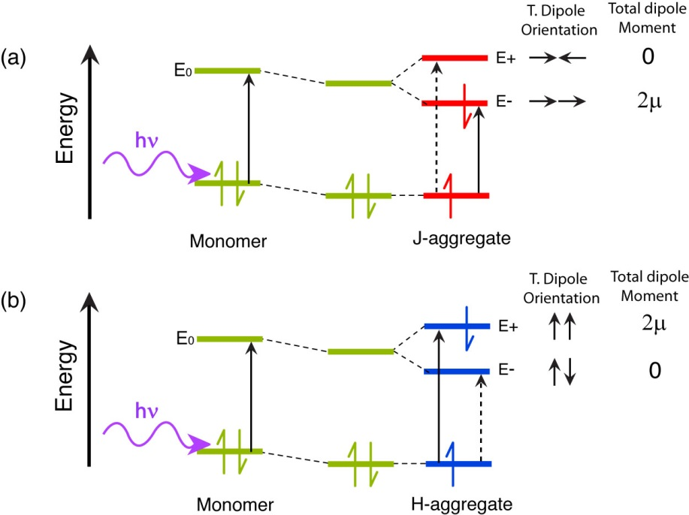

Fig 1.5. Molecular orbital illustration of (a) J-aggregate and (b) H-aggregate states. Transition dipole coupling stabilizes the dimer. The allowed transitions for each aggregate are given by the solid black arrow, and forbidden transitions are given by a dashed black arrow. Transition dipole orientations and total dipole moments are given to the right of each M.O. diagram.

Unlike H- and J-aggregates, excimers (excited dimers) and exciplexes (excited complexes) both result from an interaction of one molecule in its excited state with another molecule in its ground state. The differentiation between the two is that excimers result from RET interactions of like molecules to form an electronically neutral dimer (similar to H- and J-aggregates), whereas exciplexes result from electron transfer interactions between two chemically distinct molecules resulting in a charge transfer complex with a net zero charge.{Köhler, 2015 #184} The main factors that impact whether excimers or H- and J-aggregates form includes the structural arrangement of the molecules, and the relative transition dipole coupling strength between the interacting monomers. Excimers and H-aggregates form under similar structural arrangements; however, excimers have several differentiating characteristics from H-aggregates. Unlike H-aggregates, constituent monomers of an excimer are only electronically coupled in the excited state, and possess a dissociative ground state (the individual molecules of the dimer repel following emission). In addition to the dissociative ground state, the other distinguishing photophysical features of excimers include a broad, red-shifted emission spectrum (due to the electronic stabilization of the dimer upon formation) lacking vibronic structure, and a substantial reduction in fluorescence lifetime.{Köhler, 2015 #184} Exciplexes are formed by electron transfer between two chemically distinct molecules (e.g. following charge transfer in a bulk heterojunction), where the excited electron donor becomes positively charged, and the electron acceptor becomes negatively charged. Formation of the charge-transfer state results in either back-transfer to reform either the ground state or the Frenkel exciton on the donor, or coulombic attraction between the electron/hole pair to form the exciplex. Like excimers, exciplexes have a dissociative ground state following emission, and exhibit broad, structureless, red-shifted emission due to energetic stabilization of the charge-transfer complex. However, in contrast to excimers, exciplexes have longer lifetimes, where the exciplex state is either similar in lifetime or much longer-lived compared to the lifetime of the donor molecule, as well as a reduced fluorescence quantum yield.{Köhler, 2015 #184}{Jenekhe, 1994 #183}{Müllen, 2006 #232} Due to the conditions required for efficient electron transfer (c.f. section 1.4), exciplexes form most efficiently for cofacial arrangements of donor and acceptor, maximizing molecular orbital overlap. Exciplexes also tend to be favored in nonpolar solvents, as polar solvents stabilize the interacting charges leading to solvent-separated ion pairing and exciplex quenching.{Ghoneim, 2001 #190}

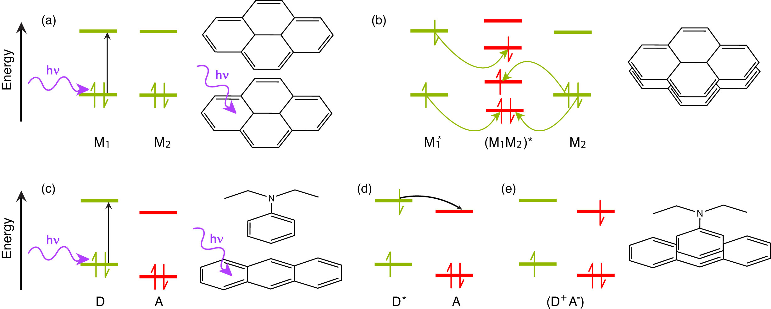

Fig. 1.6. Molecular orbital illustration of excimer (a, b) and exciplex (c-e) formation, accompanied by molecular illustrations of pyrene excimer formation (top) and anthracene/N,N-diethylaniline exciplex formation (bottom). In the excimer case, two like molecules M1 and M2 interact, with (a) M1 initially excited to M1*, followed by (b) RET (yellow arrows) to form a neutral excited dimer (M1M2)*. In the exciplex case, two distinct molecules, one electron donor D and one electron acceptor A interact. (c) The donor is excited from D to D*, followed by (d) electron transfer (black arrow) from D* to the acceptor A to form an excited state charge-transfer complex (D+A-).{Köhler, 2015 #184}

|  |  |  |  |
| --- | --- | --- | --- |
| **Aggregate**  **Species** | **Spectral**  **Signature** | **Lifetime**  **Characteristics** | **Structural Arrangement (slip)** |
| H-aggregate | Broad, blue-shifted spectra | Lifetime monomer lifetime | 54.7°–90° |
| J-aggregate | Narrow, Red-shifted spectra | Lifetime << monomer lifetime | 0°–54.7° |
| Excimer | Broad, Red-shifted spectra | Lifetime << monomer lifetime | ~90° |
| Exciplex | Broad, Red-shifted spectra | Lifetime donor lifetime | ~90° |

Table 1.1. Summary of aggregate species, spectral signatures, lifetime characteristics, and monomer structural arrangements expressed as slippage angles.

* 1. **Fluorescence Anisotropy Decay in Conjugated Polymer Nanoparticles**

Exciton transport in conjugated polymers and nanoparticles is the result of multiple energy transfer events between chromophores that are more or less indistinguishable from one transfer event to the next. It is of particular interest to understand how nanoscale structure (polymer in solution versus nanoparticles) affects the rates of exciton transport in CPs. While steady-state UV-Vis and fluorescence can help to elucidate significantly different species in the ensemble via their spectral signatures (e.g. H-/J-aggregates, chemical defects), and lifetime measurements allow for the calculation of decay rates for each distinguishable part of the ensemble, it is not possible to determine average energy transfer rates between equivalent chromophores using these methods. Fluorescence anisotropy is used as a means to quantify the polarization of the emission of a fluorophore after being excited by plane-polarized light. Typically, the excitation source is vertically polarized, and the emission is analyzed after being passed through a linear polarizer oriented parallel (0°) or perpendicular (90°) relative to the excitation source. These components of the emission are given by and , respectively, and the anisotropy *r* is then calculated by



, (1.6)



which forms a ratio of the difference between the parallel and perpendicular emission components relative to the total intensity. Extending this into the time domain, 1.6 becomes

, (1.7)



where *r*(*t*) is the fluorescence anisotropy decay (FAD), and and are the respective fluorescence intensity decays collected at 0° and 90° polarizer orientations. FAD allows us to quantify the rate at which different processes (e.g. rotation, multiple energy transfer) cause depolarization of the fluorescence signal. It is worth noting that the relative amplitude of cos2** and sin2**, where ** is the angle of the emission polarizer. When the emission polarizer is set to  = 54.7° (magic angle, ~55°), this results in cos2** = 0.333 and sin2**  , which corresponds to a twofold amplitude of the perpendicular component of the emission relative to the parallel component of the emission, or .{Lakowicz, 2006 #26} Thus, it is possible to measure the total intensity *S*(*t*) by magic angle orientation of the emission polarizer, and the anisotropy decay is calculated by



. (1.8)



Conformational disorder in CPNs results in many closely-spaced chromophores in varied orientations in space. Thus, it follows that a linearly polarized excitation source (e.g. a pulsed laser) would preferentially excite certain chromophores (those with their transition dipole moments oriented similarly to the polarized excitation pulse). In an aqueous suspension of CPNs, particles are typically large enough that rotational diffusion at room temperature occurs on time scales several orders of magnitude slower than the lifetime of the nanoparticles (rotational correlation times are tens of ns to µs, depending on particle size, whereas CPN lifetimes are typically on the picosecond time scale), which allows the assumption that any depolarization of fluorescence can effectively be ascribed to energy homotransfer events. As previously discussed, exciton homo-transfer on the ps-ns time scale is typically driven by incoherent methods of energy transfer (e.g., FRET, Dexter transfer). Given that the interchromophore distance is minimal (~1 nm) and assuming sufficient spectral overlap, the efficiency of each energy transfer event is then essentially governed by the alignment of transition dipole moments, accounted for in the 2 term in equation 1.1, which need not be perfectly aligned for energy transfer to occur. Therefore, each energy transfer event depolarizes the resulting emission (c.f. Fig 1.7). The rate of depolarization, and thus the rate of exciton motion (given by the inverse of the measured correlation time c) can be probed using picosecond fluorescence anisotropy decay. Using the assumption that the correlation time c is a measure of the time it takes for a single incoherent transfer event to occur in conjunction with the fluorescence lifetime , the average number of energy transfer events occurring within the fluorescence lifetime can be approximated by the ratio of the lifetime and correlation time. Taking the approximate number of incoherent transfer events with the exciton diffusion length *LD* (determined from numerical random walk simulations), the typical distance per energy transfer event can be determined (if ~3 transfer events occur within the fluorescence lifetime, with a 12 nm *LD*, this gives ~4 nm distance traveled per energy transfer event).

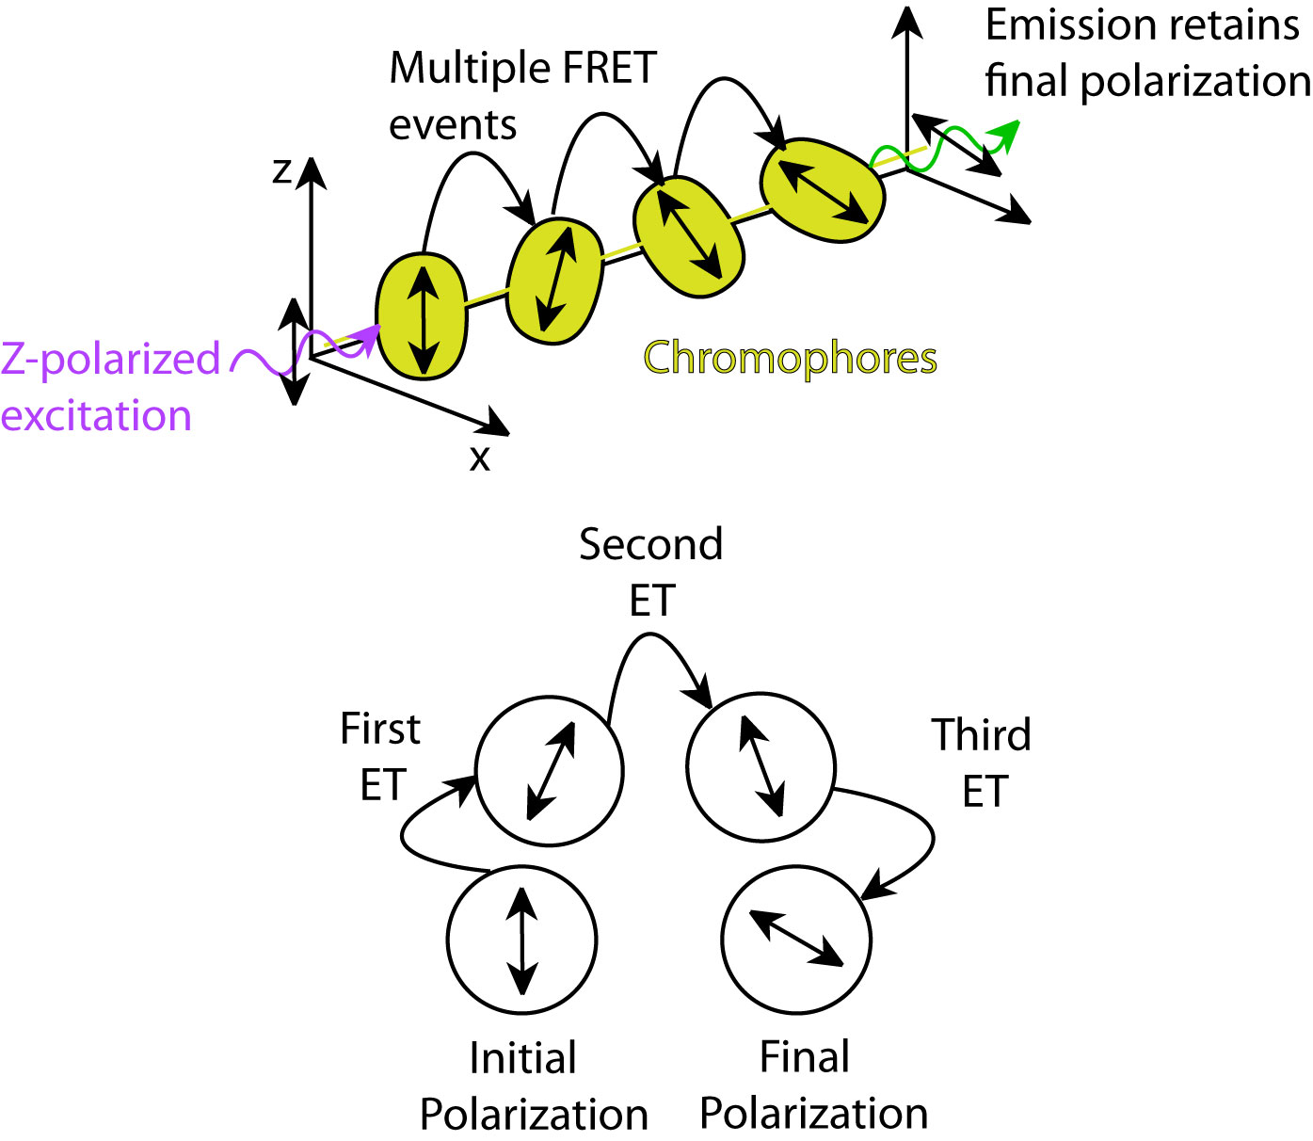

Fig. 1.7. (top) Diagram depicting polarization loss via multiple energy transfer. (bottom) Illustration of polarization changes after each FRET event.